Stratified Mortality Analysis (Kaplan-Meier)

1. Stratified by HIV Status
Group | 1 Years | 5 Years | 10 Years | 12 Years
Negative | 1.86% | 6.03% | 8.61% | 9.54%
Positive | 7.00% | 18.92% | 24.64% | NA

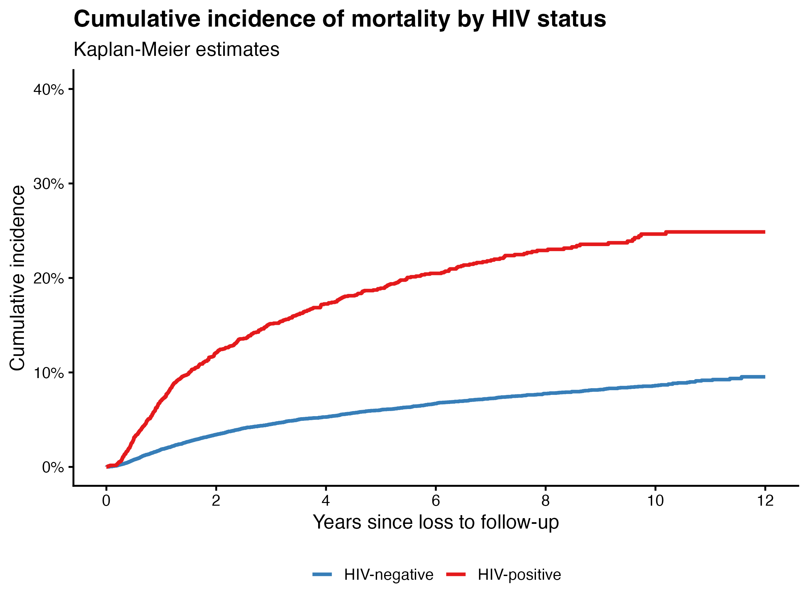

2. Stratified by Homelessness
Group | 1 Years | 5 Years | 10 Years | 11.9 Years
No | 2.18% | 6.81% | 9.56% | 10.31%
Yes | 4.27% | 12.59% | 17.47% | 18.97%

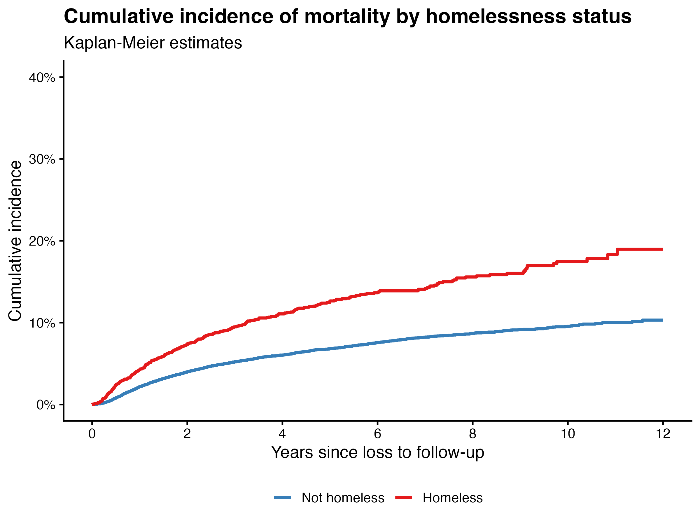

3. Stratified by Timing of Loss to Follow-up
Group | 1 Years | 5 Years | 10 Years | 11.9 Years
1 to <2 months | 5.30% | 11.88% | 14.57% | 15.61%
2 to <4 months | 2.60% | 8.12% | 11.31% | 11.57%
< 1 month | 6.60% | 12.91% | 16.40% | 16.94%
≥ 4 months | 0.95% | 5.18% | 8.07% | 9.24%

